**ASSIGNMENT DAY – 4**

**1)Find out the mail servers of the following domain:**

* **Ibm.com**
* **Wipro.com**

**Ans:**

1.goto cmd type nslookup

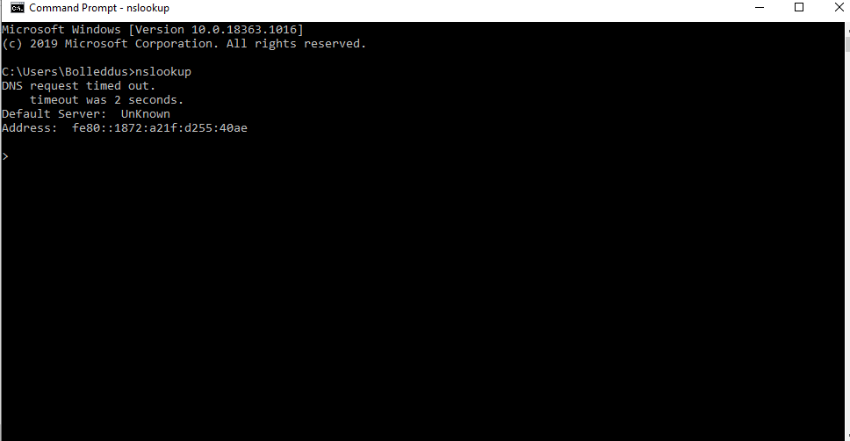

2. then type ‘set type=mx’

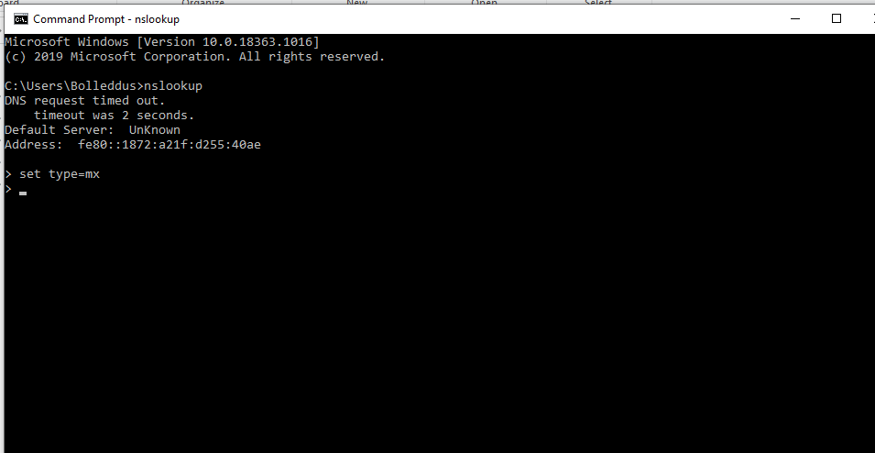

3.type the domain name here ibm.com

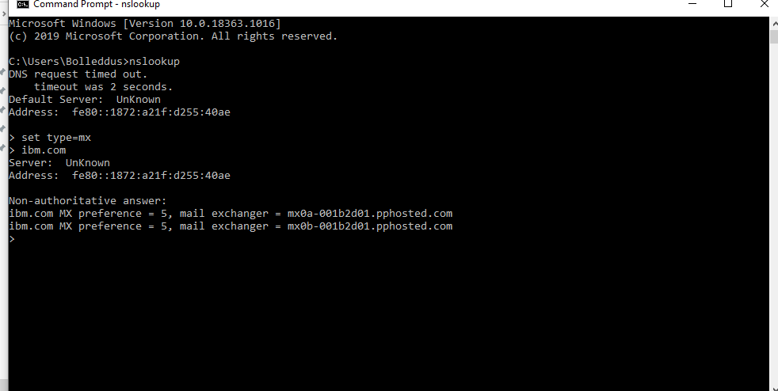

Again repeat for the same for the next domain name type wipro.com

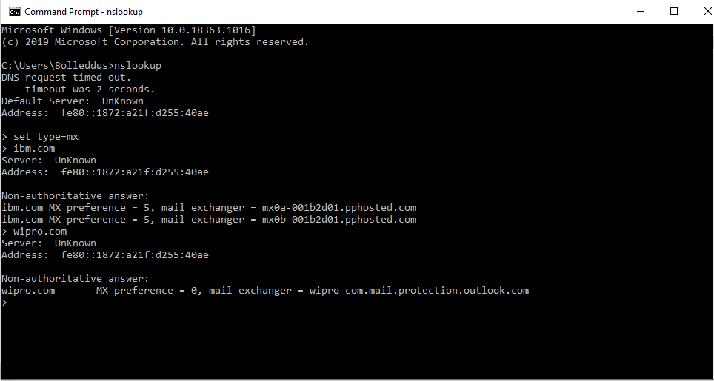

**2)find the locations, where these email servers are hosted.**

* **Ibm.com**
* **Wipro.com**

**Ans:-**

1. Go to this website

<http://my-addr.com/email_server_location/e-mail_box_server_location/locate_email_address_for_free.php?ept_email=bWFpbEBpYm0uY29t&x=0&y=0>

1. Then type the email server name [mail@wipro.com](mailto:mail@wipro.com)

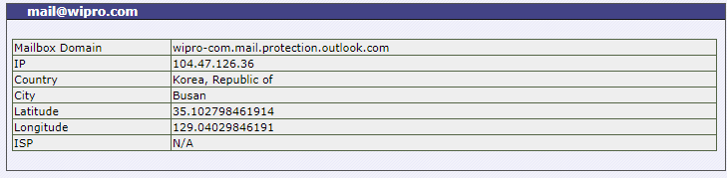

Repeat the same for the ibm

The email server name for ibm is [mail@ibm.com](mailto:mail@ibm.com) or mx0b-001b2d01.pphosted.com

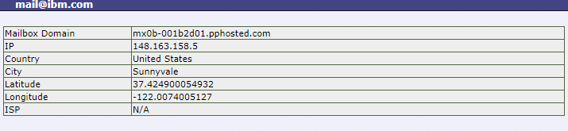

**3)scan and find out port numbers open in 203.163.246.23**

**Ans:-**

1. Launch kali vm
2. Go to terminal
3. Type nmap 203.163.246.23

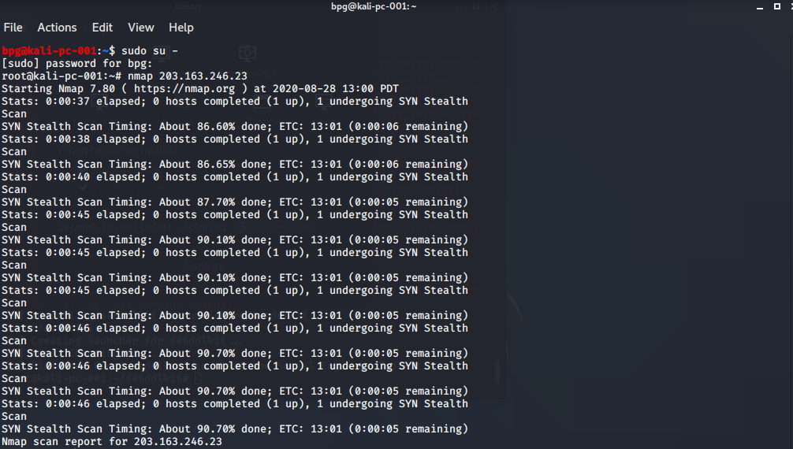

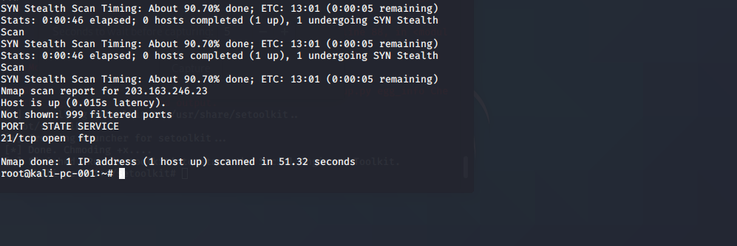

**4)Install nessus in a vm and scan your laptop/desktop for CVE**

**Ans:-**

1. **Open the pentester**
2. **Start the machine with nat on**
3. **Download nessus software by creating the account**
4. **Open the package and install it**
5. **Then goto** [**https://localhost:8834.com**](https://localhost:8834.com)
6. **Then install the plugins**
7. **Login with the administrator and password credentials**
8. **Click on create new scan**
9. **Then enter the ip address and user credentials**
10. **Then start the scan**
11. **Then you can download the scan and check the VCE**

**PICTURES ARE DOWN SOME SNAPSHOTS ARE MISSING**

